 | KM travelled | Days | Hull | Rig (Sail type) | Main Power | Backup Power | Actuators | Sensors | Communications | Computers | Other
OpenTransat (2019) | 6041 | 185.79 | -Carbon Fibre  -Kevlar  -Fibreglass  -foam core monohull | Free rotating rigid wingsail adjusted by a flap | 12.8V 30Ah LiFePo4 batteries powered by 6, 24, and 18 Watt peak solar panels | 12.8V 1600mA LiFePo4 and two 3W peak solar panels for wing sail | Brushless motor with worm drive (JGY2838)  -magnetic encoder feedback (EMS22A) for rudder control  -linear actuator (Actuonix L16-P) with magnetic encoder feedback for sail flap control | - MPU9250 with EM7180 sensor fusion co-processor compass  -UBlox Neo M8N GPS module  -custom made ultrasonic wind sensor  -sailwing position sensor (16 Hall effect sensors) | -Rockblock Iridium SBD modem  -SPOT Trace tracker | -Custom PCB based on Atmega2560 for control system.  -Raspberry Pi 3B for taking pictures | Open source design
SeaLeon (2018) | 3762.7 | 76.08 | -kevlar-carbon hybrid cloth  -foam ribs  -internal bracing | Sloop rig, single sail actuator to control main and jib | 19x Eagle Picher PT 2300 Keeper II D size lithium Thionyl 3.6V 19 Ah Batteries (system voltage of 14.4V total capacity 361 Ah) |  | -custom built  -geared brushless motors with position and speed feedback | LCJ Capteurs CV7 Wind Vane  -Honeywell HMC6343 Compass  -MTK3339 GPS | 2 Xeos ONYX-R trackers  Iridum satellite network | Atmel ATSAMD20J18 microcontroller
Breizh Tigresse (2015) | 1427 | 32.25 | Closed cell foam  -marine grade plywood  -foam blocks on transom (provide extra buoyancy counteract weight of batteries)  -layers of fibreglass filled with epoxy | Sloop rig with a single sheet | 20x Eagle Picher PT 2300 Keeper II D size lithium Thionyl 10.8 V, 19 Ah batteries (total capacity 380 Ah) |  | Sail servo: Hitec HS-785HB  Rudder servo: Hitec HS-5646W | LCJ Capteurs CV7 Wind Vane, Honeywell HMC6343 Compass and SANAV FV-M GPS | 2 Xeos ONYX-R trackers using Iridum satellite network | Microchip PIC18F2550 main card  -PIC16F628 daughter card
ABoat Time (2014) | 408 | 5.46 | -polyester fibre glass hull  -fibre glass coated plywood deck | Free-standing  -rotating gaff with fixed boom and gaff  -Battenless Dacron sail | 12V LiFe charged by 15 Watt solar panel | 6V LiPo charged by 3 Watt solar panel | Hitec HS646WP waterproof servo for rudder control  -20 RPM brushless motor driving a worm gear for sail control | Wind direction (hall effect sensor)  -6 DOF Razor IMU for compass  -GPS receiver | SmartOne Globalstar Tracker | Arduino Mega Pro 2560t
That’ll do (2016) | 374 | 4.875 | -custom moulded GRP | Class rigged sails | -1500mA (nav system)  -1200 mA (satellite comms system)  -4x 9V solar panels | -2x 3.7V 6Ah LiPo batteries | -Futaba S3003 rudder servo | CMPS11 digital compass  -GPS | RockBlock Iridium Short Burst Data Modem | Picaxe
EC Crossing |  |  | Foam core fibreglass monohull with moulded one piece keel. |  | 4.5Ah Lead Acid Battery mounted in the keel and 10Wpeak 12V solar panel on the deck. |  | HiTec HS5086WP metal geared waterproof servo. | CMPS11 digital compass, UBlox-7 GPS and a DS18B20 temperature sensor mounted in keel | RockBlock Iridium Short Burst Data Modem | 2X PIC18F25K22s | Version 1 of the software was first written by students in 2015 and tested on a remote controlled car, which could drive itself around our fields

Power Table (How long it lasts)
Boat | Main Power | Backup Power | Days | Outcome
OpenTransat (2019) | 12.8V 30Ah LiFePo4 batteries powered by 6, 24, and 18 Watt peak solar panels | 12.8V 1600mA LiFePo4 and two 3W peak solar panels for wing sail | 185.79 | Launched July 8th. It made continual but slow progress East until October 18th. After this it began to sail in large circles and from October 25th messages became less frequent, possibly due to failing batteries or a lack of sunlight on the solar panels.
SeaLeon (2018) | 19x Eagle Picher PT 2300 Keeper II D size lithium Thionyl 3.6V 19 Ah Batteries (system voltage of 14.4V total capacity 361 Ah) |  | 76.08 | Launched July 30th. After September 25th the course became increasingly erratic with several circles, slow movement and eventually tracking stopped on October 14th.
Breizh Tigresse (2015) | 20x Eagle Picher PT 2300 Keeper II D size lithium Thionyl 10.8 V, 19 Ah batteries (total capacity 380 Ah) |  | 32.25 | Departed September 1st. It sailed steadily east until September 9th when it was just North of Sable Island. After this the course became erratic first heading north, then looping, heading south, continuing east and eventually looping several more times before tracking messages stopped on October 4th.
ABoat Time (2014) | 12V LiFe charged by 15 Watt solar panel | 6V LiPo charged by 3 Watt solar panel | 5.46 | Began May 16th 2014. On May 22nd she was accidentally caught in the nets of the scallop dragger Atlantic Destiny based in Halifax, Nova Scotia. The crew were able to bring her on board and contacted the team. They noticed some small damage to the solar panels.
That’ll do (2016) | -1500mA (nav system)  -1200 mA (satellite comms system)  -4x 9V solar panels  - | 2x 3.7V 6Ah LiPo batteries | 4.875 | Launched July 5th. Unfortunately the boat didn't make much progress west and was pulled east by the tide and wind. It stopped transmitting position reports on July 10th approximately 40 nautical miles/74 km East of the start position.
EC Crossing (2019) | 4.5Ah Lead Acid Battery mounted in the keel and 10Wpeak 12V solar panel on the deck. |  | 3.2 | Launched on September 14th from just South of Selsey, West Sussex in England. It moved South, oscillating from an East to West with the tide and contact was lost on September 18th.
Navigation Table (How straight it goes)
Boat | Actuators | Sensors | Computers | Path
OpenTransat (2019) | Brushless motor with worm drive (JGY2838)  -magnetic encoder feedback (EMS22A) for rudder control  -linear actuator (Actuonix L16-P) with magnetic encoder feedback for sail flap control | - MPU9250 with EM7180 sensor fusion co-processor compass  -UBlox Neo M8N GPS module  -custom made ultrasonic wind sensor  -sailwing position sensor (16 Hall effect sensors) | -Custom PCB based on Atmega2560 for control system.  -Raspberry Pi 3B for taking pictures | 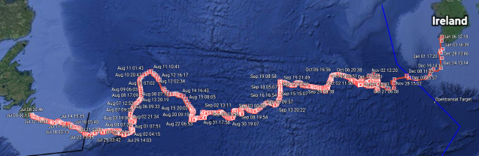
SeaLeon (2018) | -custom built  -geared brushless motors with position and speed feedback | LCJ Capteurs CV7 Wind Vane  -Honeywell HMC6343 Compass  -MTK3339 GPS | Atmel ATSAMD20J18 microcontroller | 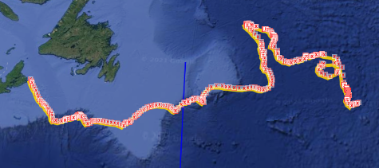
Breizh Tigresse (2015) | Sail servo: Hitec HS-785HB  Rudder servo: Hitec HS-5646W | LCJ Capteurs CV7 Wind Vane, Honeywell HMC6343 Compass and SANAV FV-M GPS | Microchip PIC18F2550 main card  -PIC16F628 daughter card | 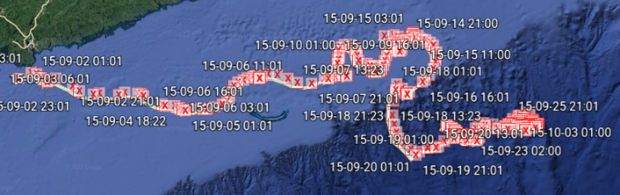
ABoat Time (2014) | Hitec HS646WP waterproof servo for rudder control  -20 RPM brushless motor driving a worm gear for sail control | Wind direction (hall effect sensor)  -6 DOF Razor IMU for compass  -GPS receiver | Arduino Mega Pro 2560t | 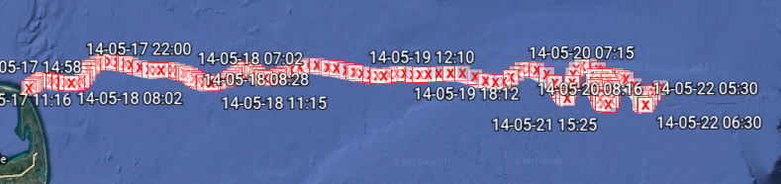
That’ll do (2016) | -Futaba S3003 rudder servo | CMPS11 digital compass  -GPS | Picaxe | 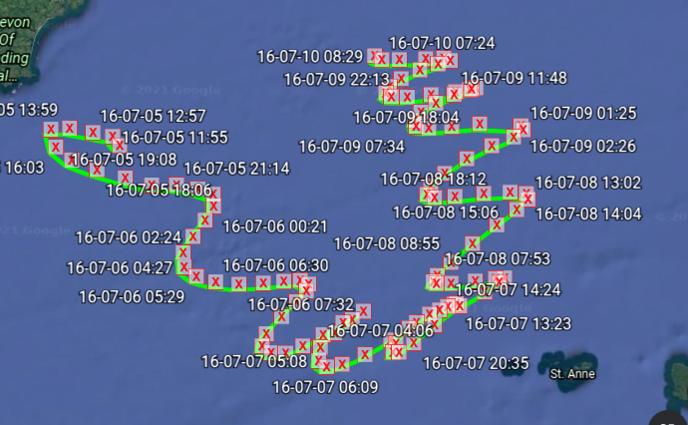
EC Crossing (2019) | HiTec HS5086WP metal geared waterproof servo. | CMPS11 digital compass, UBlox-7 GPS and a DS18B20 temperature sensor mounted in keel | 2X PIC18F25K22s | 